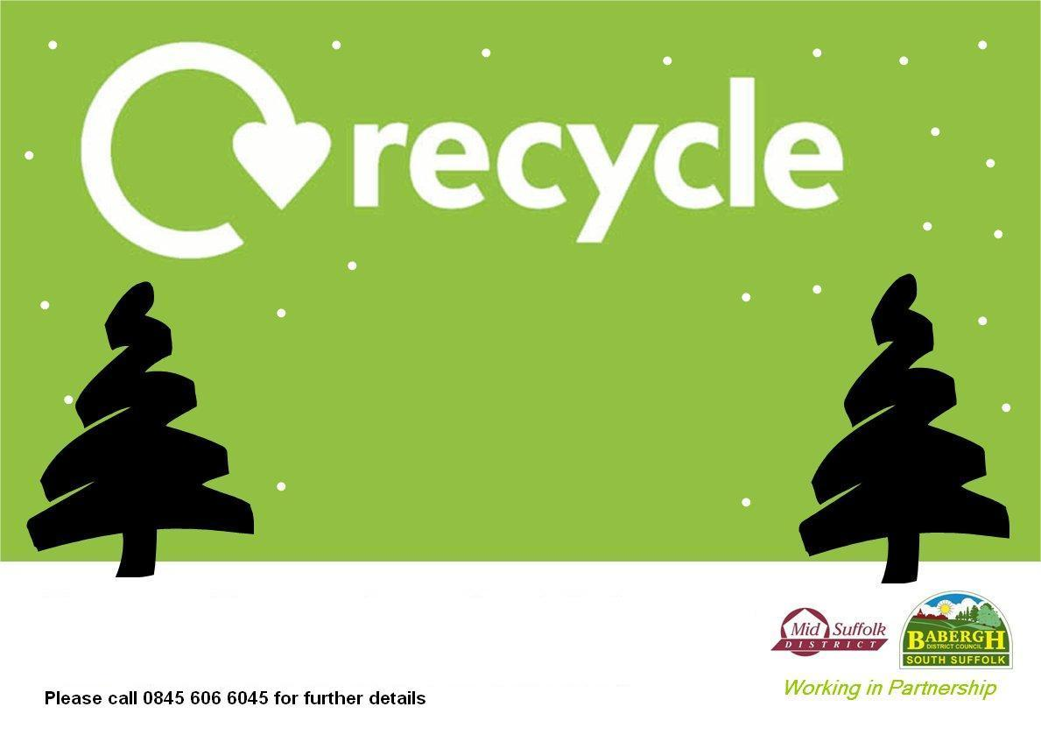

**Your real**

**Christmas tree**

**In Chelmondiston at**

**Collimer Close Car Park**

**Trees can be left at this collection point on Saturday 2nd January and Sunday 3rd January.**

**Collection will be made from 6.30am on Monday 4th January.**

**Trees must be less than 7’ tall & must have all decorations, stands & pots removed. Please call 0300 1234 000 (Option 4) for further details.**

